**Sprint - 4**

**Deploy application using Docker & Kubernetes**

|  |  |
| --- | --- |
| Sprint Date | 18 November 2022 |
| Project Name | Project - Smart Fashion Recommender Application |

**Push project in Docker:**

**Screenshots:**

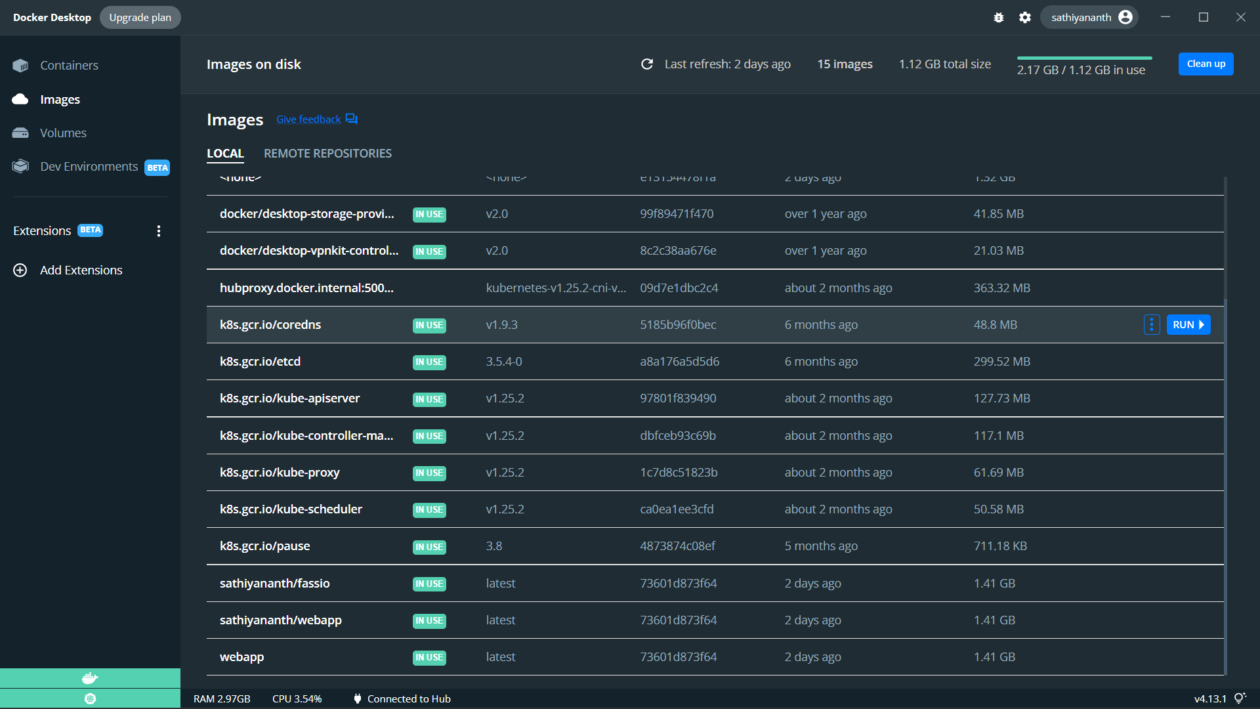

**Deploy in Kubertenes:**

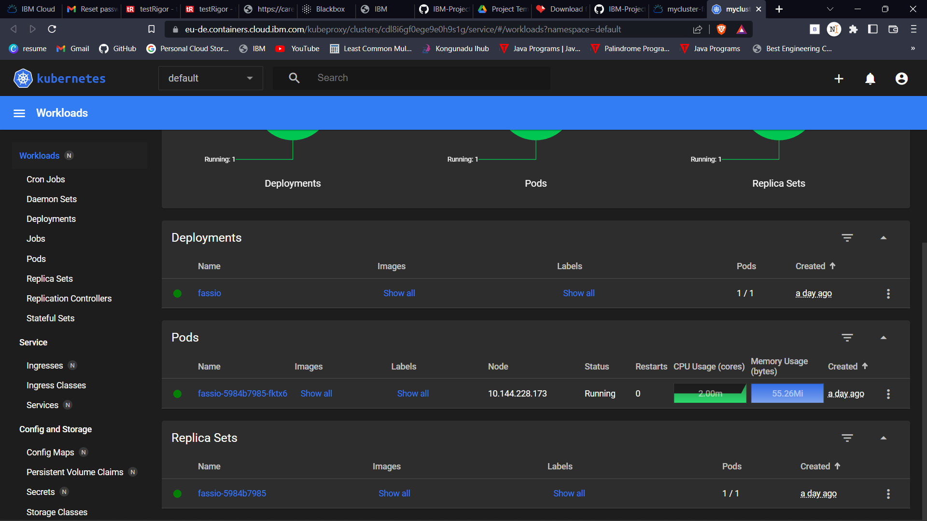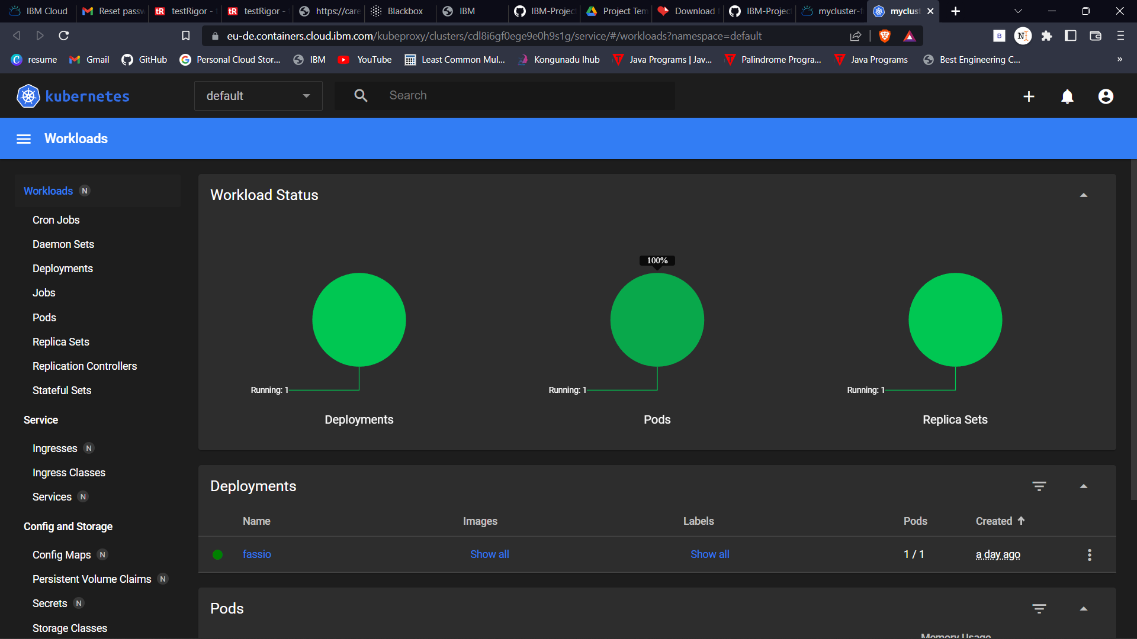

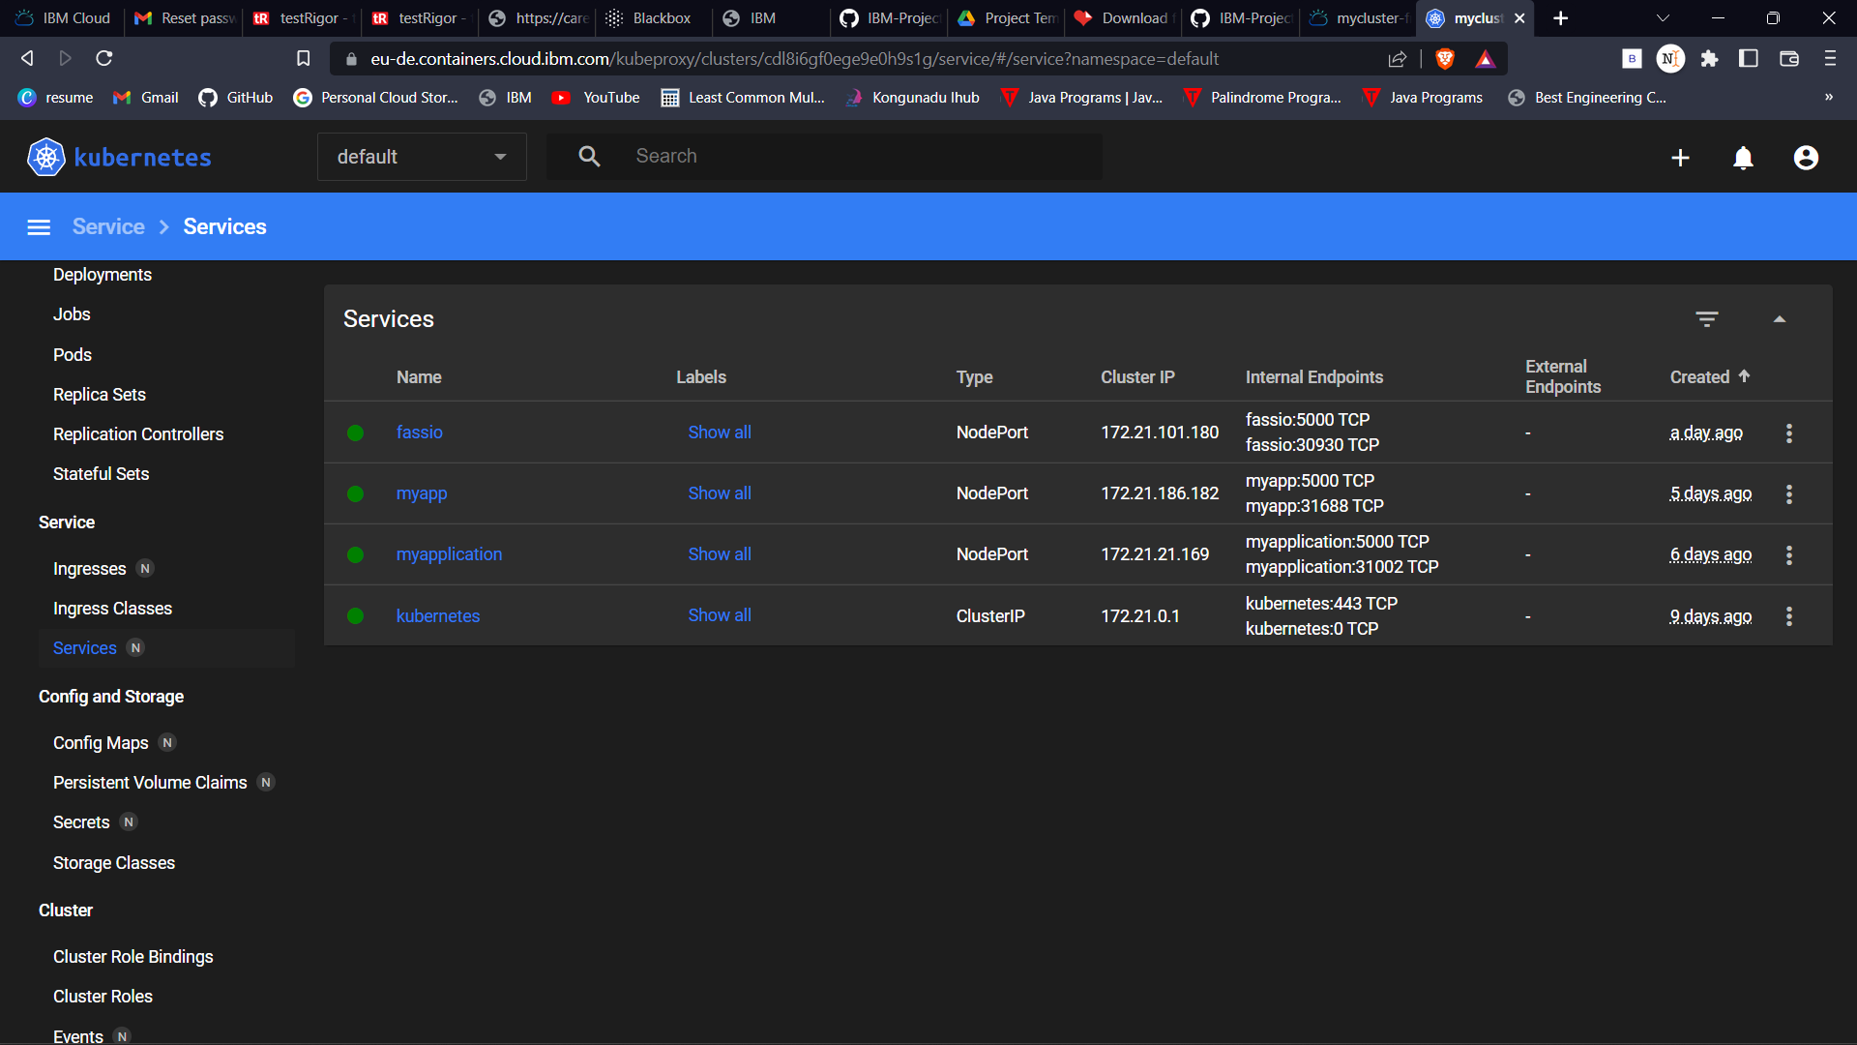

**Web App Link:**

http://159.122.175.66:30930/